1. **➤ Define light diffraction**

Is the interference and trajectory deviation when wavelengths find an obstacle. Also known as the bending of light around obstacles or slits of similar size to the incident wavelength.

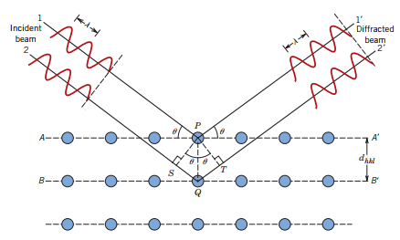

1. **➤ What are x-rays? who discover them, and when? Why are they called “x-rays”?**

They are high energy electromagnetic (ionizing) radiation with wavelengths between 0.01 and 10nm. (frequencies between 3x10ˆ16 to 3x10ˆ19 Hz and possessed energy between 100 eV and 100 KeV).

Discovered by Wilhelm Conrad Roentgen (Nobel Prize in Physics, 1901) in 1895.

They are called X-Rays because Wilhelm Roentgen called the phenomena “X-radiation” because he didn't know what it was. ...

1. **➤ How are x-rays produced?**

They are the product of the collision of high-speed electrons against a metal target.

X rays are produced whenever highspeed electrons collide with a metal target. A source of electrons-hot W filament, a high accelerating voltage between the cathode (W) and the anode and a metal target, Cu, Al, Mo, Mg. The another is a water-cooled block of Cu containing desired target metal.

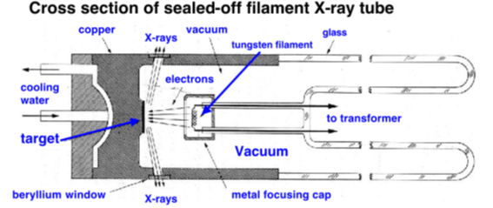

1. **What are radiations Kα, Kβ, Lα, Lβ in x-rays? What is the in Kα Cu?**

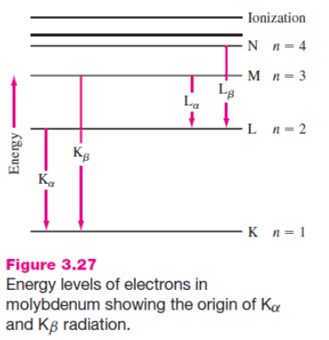

1. **➤ What are some general applications of x-rays?**

Photographs made with X rays are known as radiographs or skiagraphs. Radiography has applications in both medicine and industry, where it is valuable for diagnosis and nondestructive testing of products for defects

X-rays can also be used to kill cancer cells, but also kill healthy cells, so must be used with much care.

Other uses are in industry, at airports to check customers and baggage and by art historians to see if a picture has been painted on top of an older one.

X-ray diffraction is also very important in spectroscopy and as a basis for X-ray crystallography. The diffraction of X-rays by a crystal where the wavelength of X-rays is comparable in size to the distances between atoms in most crystals is used to disperse X-rays in a spectrometer and to determine the structure of crystals or molecules.

1. **➤ Why can x-rays be used in characterization of materials?**

The origin of X-ray is from the radiation of electrons outside the nucleus. The energy of X-rays is thus comparable with the energy level of the electrons in the atoms. When it comes to a sample, it interacts with the electrons bound in an atom.

Also because it is a non-destructive analytical method which can be used to identify phase and orientation, determine structural properties, measure the thickness of thin film, estimate the size of nanoparticles, etc..

1. **➤ Describe the Von Loue’s experiment**

Max Von Laue considered that if x-rays were waves, then they should be diffracted by the atoms in a crystal

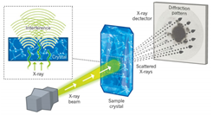

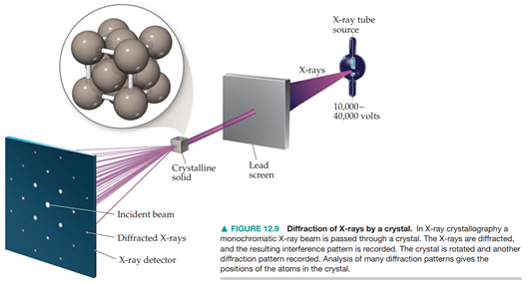

1. **➤ What is the difference in patterns between single crystals and polycrystalline materials? Explain that difference**

X-rays diffracted from a single crystal produce a series of spots in a sphere around the crystal

Polycrystals (Powders): Continuos Debye rings

Linear diffraction patterns with discrete reflections obtained by scanning through arc that intersects each Deby cone at a single point

1. **➤ Explain the W.L Bragg experiment**

Bragg through his experiments investigated the “Bragg reflection” at an NaCl monocrystal using x-ray radiation. Through this experiment he developed the known “Bragg’s Law” (of reflection). The apparatus of the experiment included a basic x-ray apparatus, an x-ray tube, a goniometer, and NaCl crystals.

When exposing the crystal to parallel x-rays, each element in a lattice plane acts as a “scattering point” at which reflection takes place of circular wavelet forms. Bragg realized that the regular arrangement of atoms in a crystal can be understand as lattice element arrays.

1. **➤ Why W.L Bragg and his son won the Nobel prize in 1915?**

W. Henry and W. L. Bragg performed the first diffraction measurements.  
They found diamond’s crystalline structure by XRD in 1913, showing that **carbon is tetravalent**, winning the Nobel Prize in 1915.

1. **➤ Explain Bragg’s Law**

When a crystal is bombarded with X-rays of a fixed wavelength at certain incident angles, reflected X-rays are produced when the wavelengths of the scattered X-rays interfere. For the waves to interfere, the differences in the travel path must be equal to multiples of the wavelength. The interference generates a diffracted beam of X-rays from the crystal at an angle equal to that of the incident beam. The general relationship between the wavelength of the incident X-rays, angle of incidence and spacing between the crystal lattice planes of atoms is known as Bragg's Law.

= reflection order

= wavelength

= interplanar distance

= incidence angle

1. **➤ What is it used for?**

When x-rays are scattered from a crystal lattice, peaks of scattered intensity are observed which correspond to the following conditions:

* The angle of incidence = angle of scattering.
* The pathlength difference is equal to an integer number of wavelengths.

The condition for maximum intensity contained in Bragg's law above allow us to calculate details about the crystal structure, or if the crystal structure is known, to determine the wavelength of the x-rays incident upon the crystal. Usually most X-ray diffractometers use the wavelength of copper Kalpha.

1. **➤ What are the components of an x-ray diffractometer?**

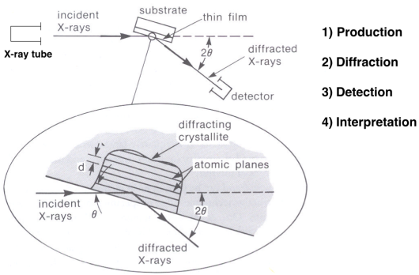

You need to be aware of sample preparation depending on each specific equipment. Sample should be a powder, but orientation is key.

1. **➤ What is an x-ray pattern? Also called x-ray diffractrogram**

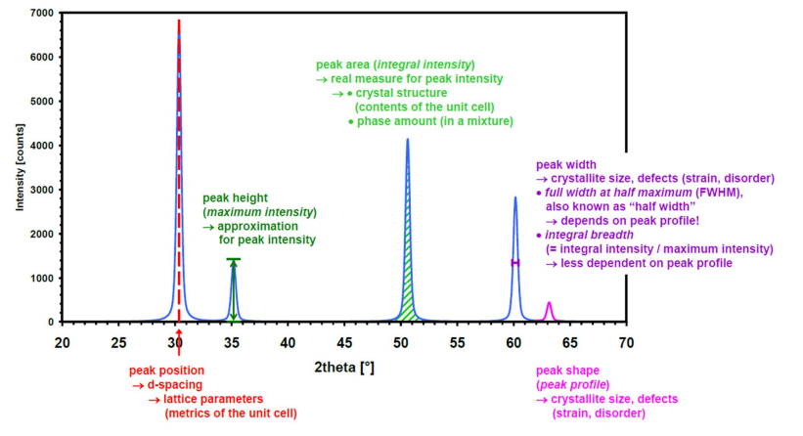

An X-ray diffraction pattern is a plot of the intensity of. X-rays scattered at different angles by a sample.

The detector moves in a circle around. the sample.

–The detector position is recorded as the angle 2theta (2θ)

–The detector records the number of X-rays observed at each angle 2θ

–The X-ray intensity is usually recorded as “counts” or as “counts per second”

Many powder diffractometers use the Bragg-Brentano parafocusing geometry

The diffraction pattern is a product of the unique crystal structure of a material.

It contains information about the atomic arrangement.

1. **➤ What kind of information can be obtained from an x-ray pattern?**

Lattice parameters, maximum intensity (not always proportional to compound concentration), crystal structure, phase amount in a mixture, crystallite size and defects.

1. **➤ Solve examples on slides 29 - 31**

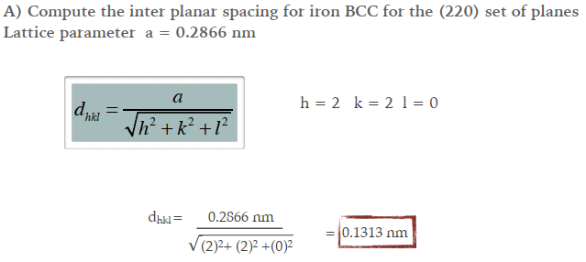

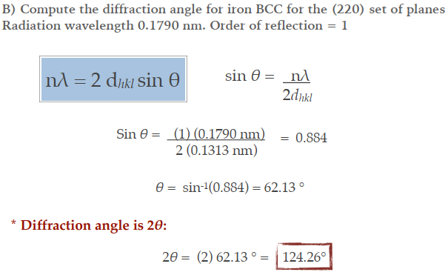

.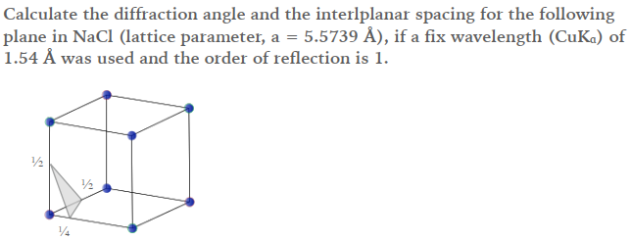.

a=0.55739nm

Lambda=0.154nm

Plano (2,4,2)

D_hkl=0.11378nm

SinO=0.68

Angulo= 42.59°

2*Angulo=85.18°

1. **➤ What are the applications of x-rays in characterization of materials?**

* Phase determination through the identification of crystalline phases
* Calculation of lattice parameters as the structure varies under different conditions
* Analysis of crystallite size and strain (crystallite domain and disorder)
* Quantitative phase analysis through the relative composition of mixed phases

**Dynamic Light Scattering Discussion Questions**

1. **What is DLS?**

It’s a technique in physics that can be used to determine the size distribution profile of small particles in suspension or polymers in solution. To use this technique is necessary a light source, a light detector, and a scattered light detector.

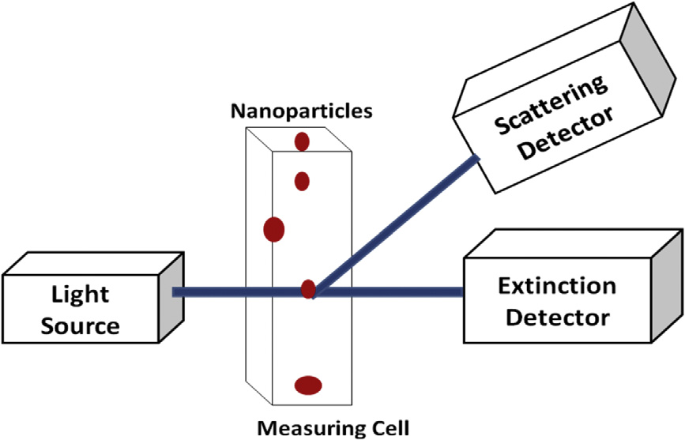

* 1. **Explain the basic principle**

The sample is illuminated by a laser beam and the fluctuations of the scattered light are detected at a known scattering angle θ by a fast photon detector. Simple DLS instruments that measure at a fixed angle can determine the mean particle size in a limited size range. More elaborated multi-angle instruments can determine the full particle size distribution.



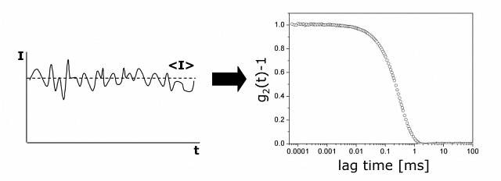



* 1. **How light interacts with nanoparticles during DLS measurements?**

Particles are exited with a laser, whose scatter some of the light that hits them. The particles scatter the light and thereby imprint information about their motion. Analysis of the fluctuation of the scattered light thus yields information about the particles. If the particles are completely still, we will measure a constant intensity of scattered light. However, in dispersion diffusion causes the intensity of the scatted light to fluctuate.

1. **Describe how DLS is used for materials and nanomaterials characterization Osamu**

DLS is used to characterize particle size and size distribution, as well as growth kinetics (changes in particle size due to aggregation). This technique also provides a means to measure molar mass of macromolecules with size and shape information. The light scattering intensity can be related to solution concentration.

1. **What are the range of size that DLS can measure?**

Lower size limit around 1nm. Can measure particles up to few microns in size.

1. **What does it mean, or what does a DLS measurement of particles indicate?** DLS measurement canbe used to determine the size of the particles and their distribution in emulsions, sols, nanoparticles, powders, polymers or latexes. It can also tell us if the particles have aggregated or give a signal of polymer chains growth in emulsion polymerization.
2. **Can DLS measure non-spherical particles?**

Yes, DLS can also give information about particle shape and in the case of non-spherical particles, the hydrodynamic radius (which is not an actual radius for these particles) is used as an estimate. The hydrodynamic radius is defined as the size of a spherical particle that diffuses at the same rate as the actual particle.

1. **What is Z-potential? Montse**

Zeta-potential (ζ) measures surface charge for particles in a specific liquid medium

•Charged particles are surrounded by an ionic double layer (nearer ion layer attached to particle; a diffuse layer away from surface)

•Slipping plane: boundary between electric double layer and ions in equilibrium in the solution

Zeta potential is the potential (mV) at the slipping plane.

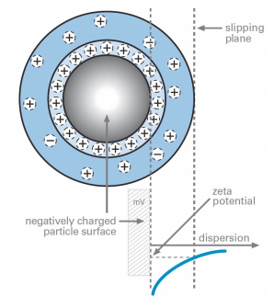

Zeta potential is a scientific term for electrokinetic potential in colloidal dispersions. In the colloidal chemistry literature, it is usually denoted using the Greek letter zeta (ζ), hence ζ-potential.

The usual units are volts (V) or millivolts (mV).

From a theoretical viewpoint, the zeta potential is the electric potential in the interfacial double layer (DL) at the location of the slipping plane relative to a point in the bulk fluid away from the interface. In other words, zeta potential is the potential difference between the dispersion medium and the stationary layer of fluid attached to the dispersed particle.

The zeta potential is caused by the net electrical charge contained within the region bounded by the slipping plane, and also depends on the location of that plane.

* 1. **What is the relation between Z potential and stability of nanoparticle suspension?**

The zeta potential is a key indicator of the stability of colloidal dispersions. The magnitude of the zeta potential indicates the degree of electrostatic repulsion between adjacent, similarly charged particles in a dispersion. For molecules and particles that are small enough, a high zeta potential will confer stability, i.e., the solution or dispersion will resist aggregation. When the potential is small, attractive forces may exceed this repulsion and the dispersion may break and flocculate. So, colloids with high zeta potential (negative or positive) are electrically stabilized while colloids with low zeta potentials tend to coagulate or flocculate as outlined in the table

Particle suspensions are usually stable if | ζ | > 25-30 mV